Experiment-11

Change Hardware compatibility of a VM (Either by clone/create new one) which is already created and configured.

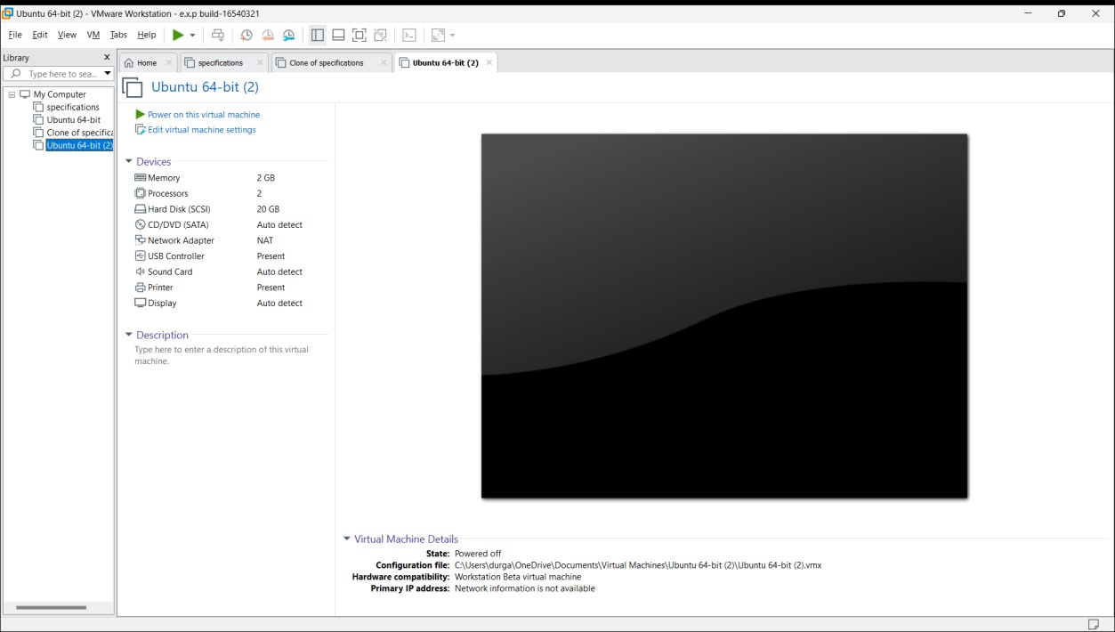

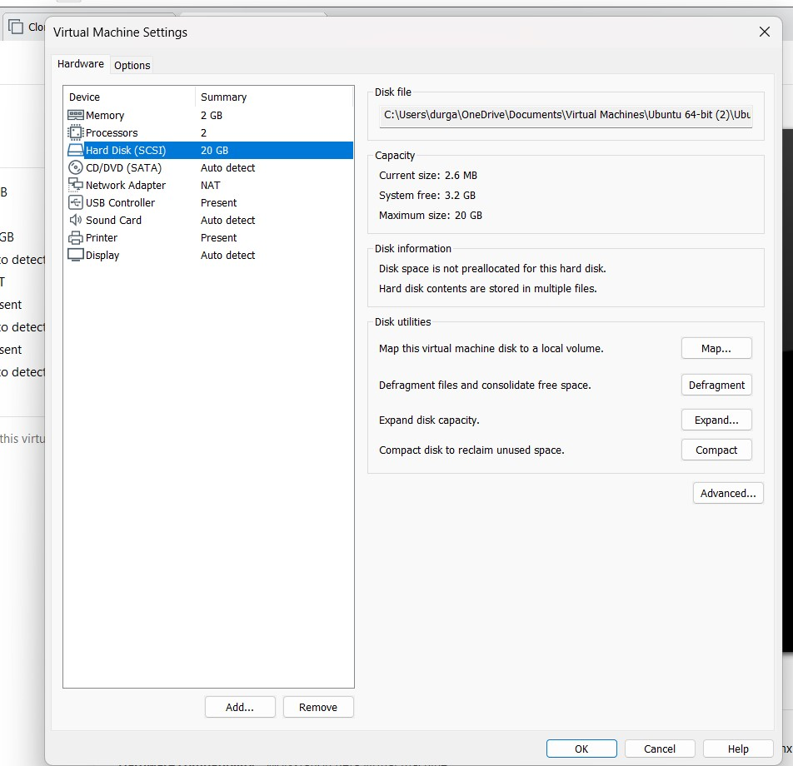

1. Vamsi K {192210355}

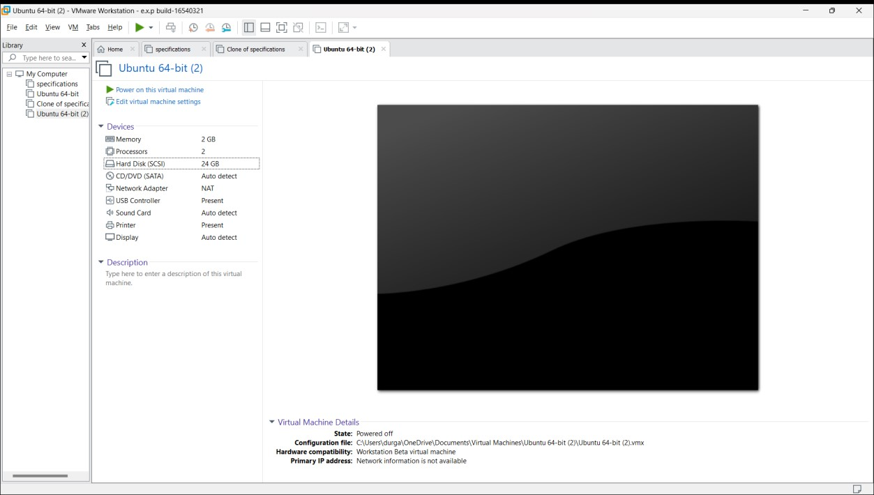

1. Vamsi K {192210355}